Lao National day

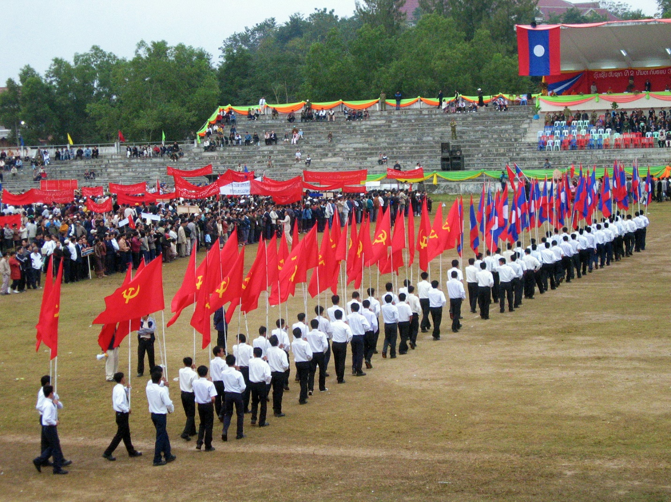

December 2, 1975, the Pathet Lao (literally "the Lao people," the name of the Communist Party) announces the abolition of the monarchy (as of 29 November, the King and Queen Savang Vatthana Khamphoui are forced to abdicate), and proclaims the democratic Republic of Laos. Prince Souphanouvong Thao is then sworn in President.

The new flag is introduced: blue, white and red ... the color red represents the blood shed for independence, and the blue represents the Mekong, or health of the country. The white disc symbolizes the moon over the Mekong, or the unity of the country under the Communist government.

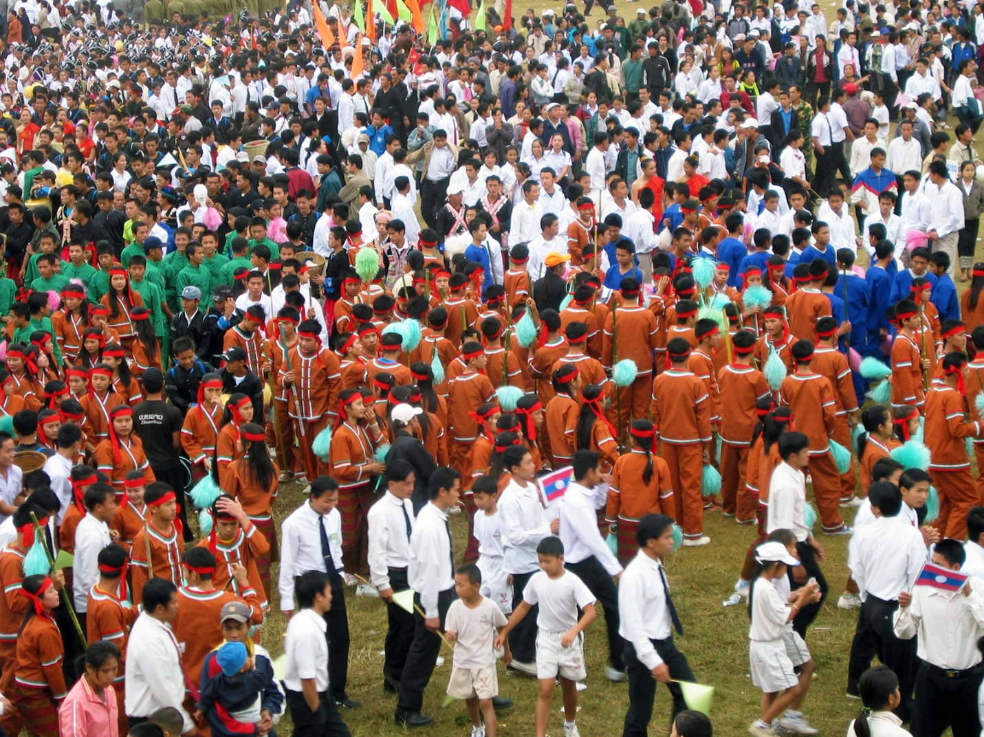

Each year takes place on this occasion a rally at the first light of day. Village by village, under large banners glorified this day, people gather. In Luang Prabang, this is the new stadium that converges all formations, silently, almost reverently. Some ethnic groups have donned their costumes and parade proudly. It’s very surprising to find that peace reigns in the city on that day. Most people celebrate the anniversary at home with friends.

